

CSE302 (Section 1)
[Summer 2022]

Lab Assignment Submission Report

Assignment Title: Lab tasks of LAB00

Submitted by:
Aisha Siddika Mim
2020-1-60-040

1. Screenshots

Problem 1:

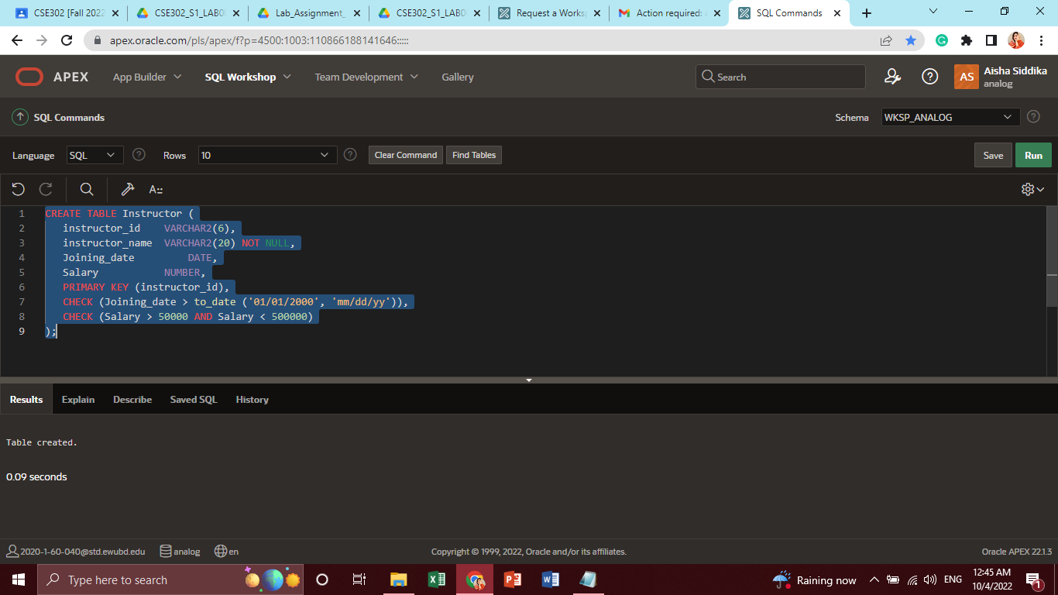

Problem 2:

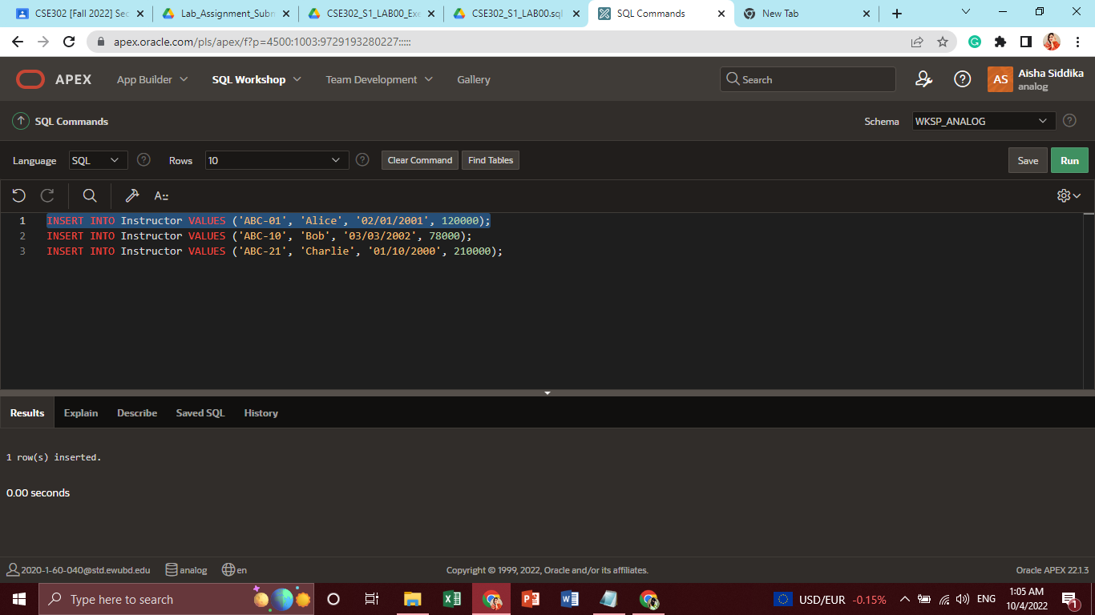
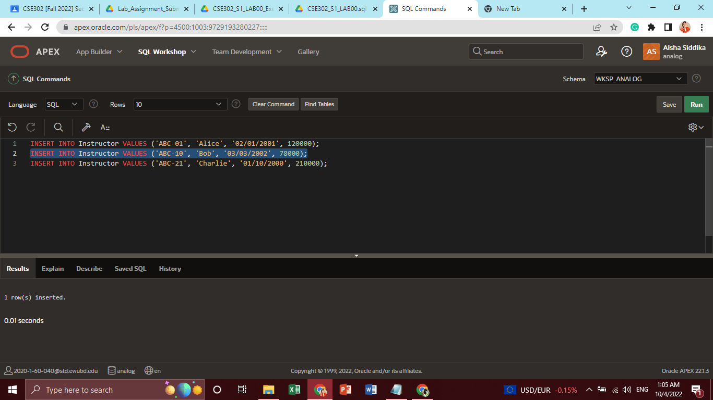

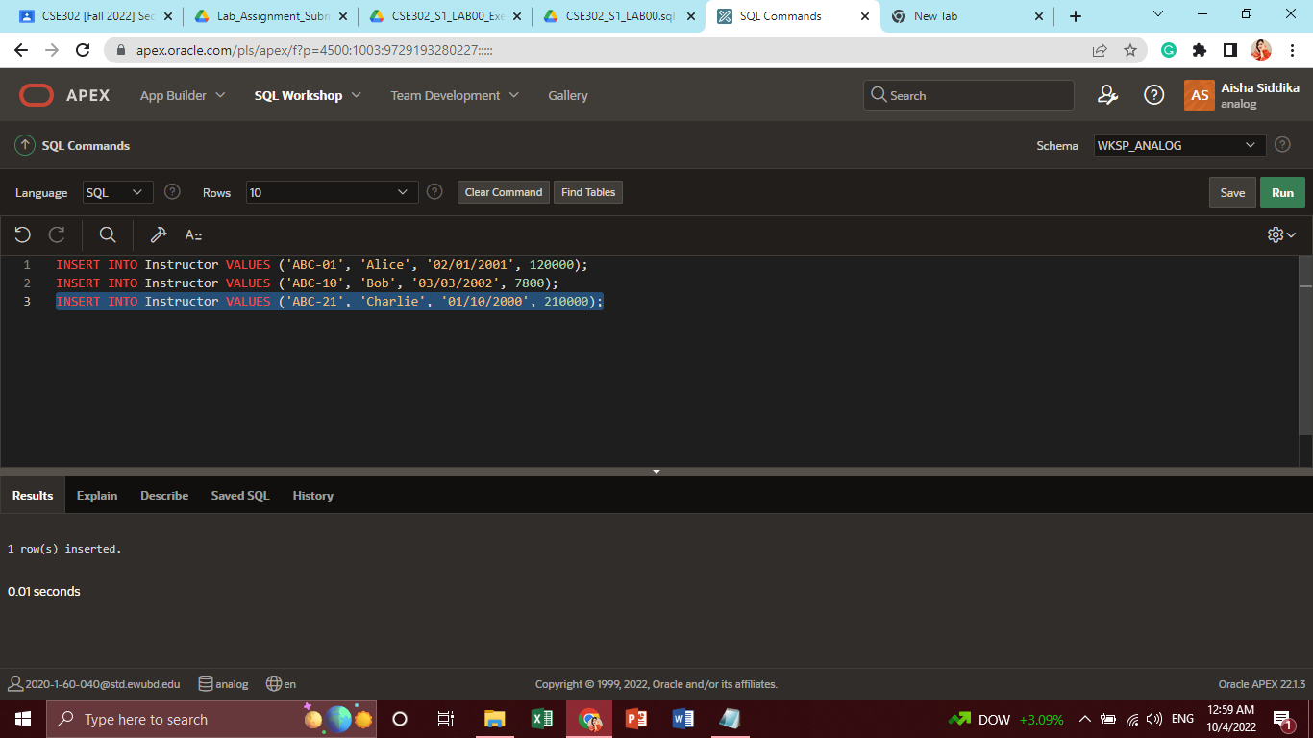

Problem 3:

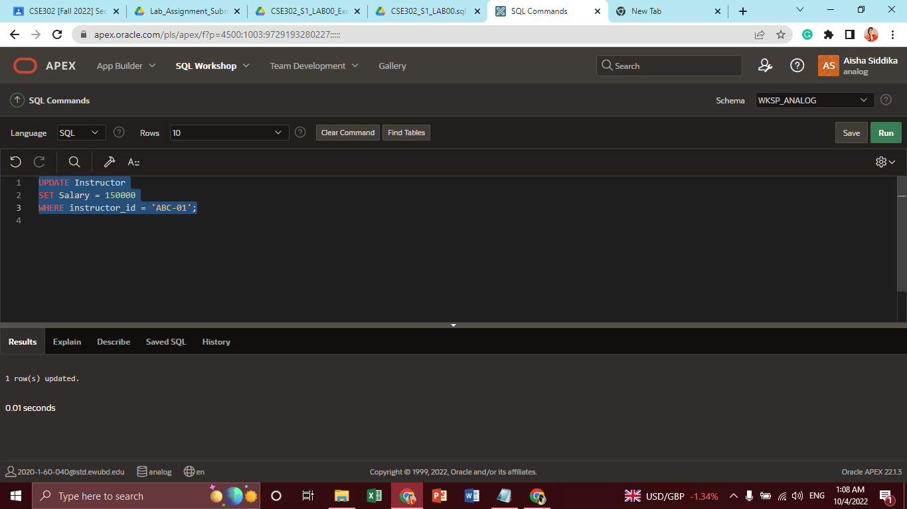

Problem 4:

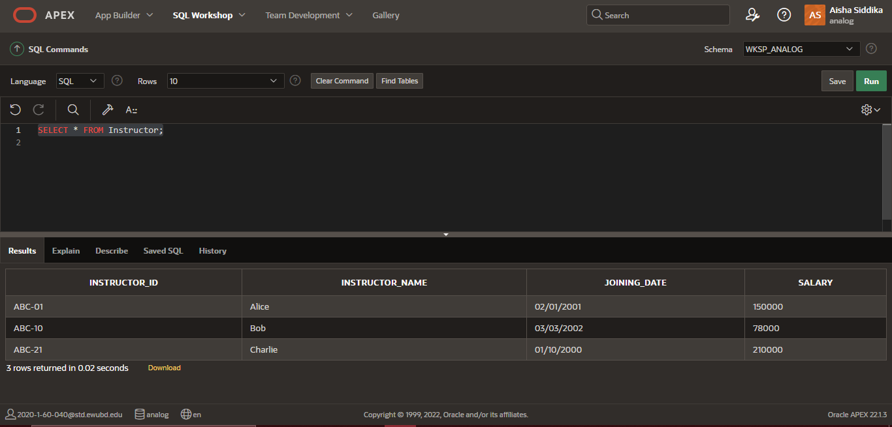

Problem 5:

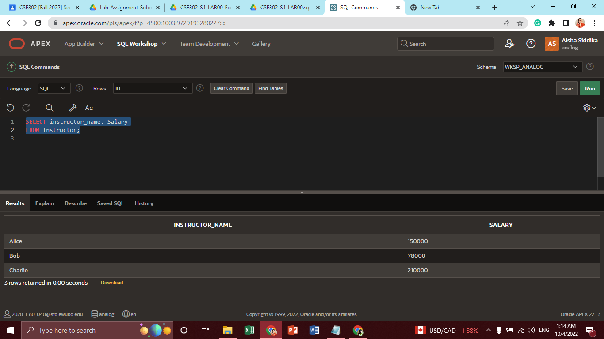

Problem 6:

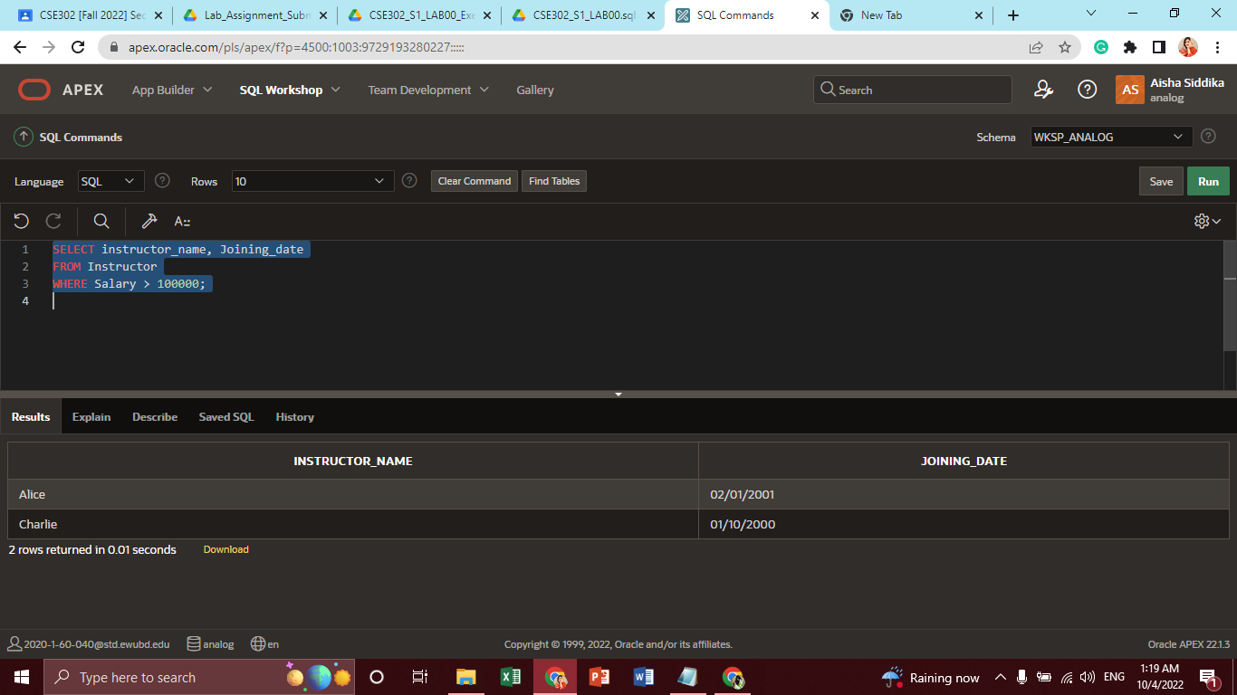

Problem 7:

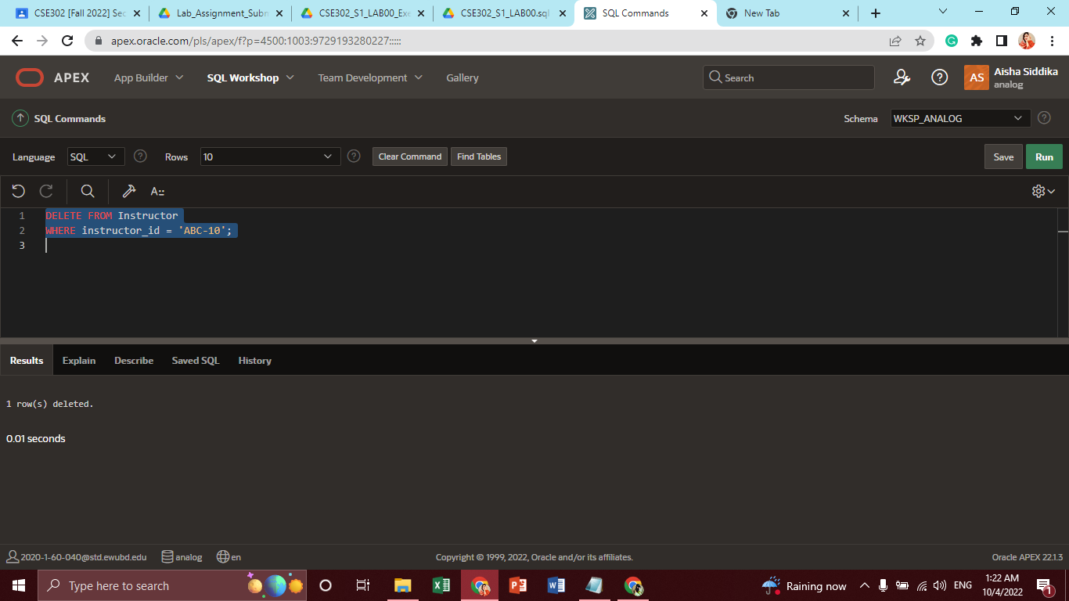

2. Learning Outcomes

Through the assignment, I learned how to use SQL workshop. Also, by using SQL commands I have created a table, inserted records in the table, updated record and showed all records in this lab task. Further, I have shown some records based on required conditions and deleted necessary records from the table.

